Overview of the project and the approach:
- What it does: Monitors GitHub pull request compliance across an organization. It enforces that merged PRs have at least one approved review and passing status checks, producing metrics and optional reports/loads to Snowflake.
- Architecture: Apache Airflow DAG (github_pr_compliance) orchestrates an ETL:
- Extract: Calls GitHub API (handles pagination, rate limits, concurrency) to gather merged PR metadata, reviews, status checks, and commits.
- Transform: Validates structure, derives compliance flags (code_review_passed, status_checks_passed, is_compliant), and computes counts (reviews, approved reviews, status checks, commits).
- Load: Writes Parquet outputs locally; optionally loads to Snowflake. Can also generate HTML/JSON reports.
- Storage paths: data/raw/ for JSON snapshots; data/processed/ for Parquet metrics; logs/ for Airflow logs. Snowflake load is gated by SNOWFLAKE_ENABLED.
- Runtime: Packaged in Docker with Airflow Webserver + Scheduler + Postgres via docker compose. Airflow admin user is provisioned (admin/admin) through airflow-init.
- Configuration:
- Airflow Variables: GITHUB_OWNER, GITHUB_ACCESS_TOKEN, SNOWFLAKE_ENABLED.
- Optional Airflow Connection: github_default (HTTP to https://api.github.com) and Snowflake connection configured via UI when enabled.
- Reliability & safeguards:
- Rate-limit handling with backoff and retries (tenacity/aiohttp/requests).
- Concurrency control on GitHub API calls.
- Schema validation via Pydantic; transformation-level checks and logging.
- Partition-friendly Parquet outputs, with metadata columns for provenance.
- Scheduling: Daily at midnight (UTC) by default; can be triggered ad-hoc via the Airflow UI.
- Extensibility:
- Add more compliance rules in the transformer (e.g., required labels, branch policies).
- Plug in additional sinks in the loader (other warehouses or BI exports).
- Adjust schedule or parameters via Airflow without changing code.
Results Pictures
DAGS
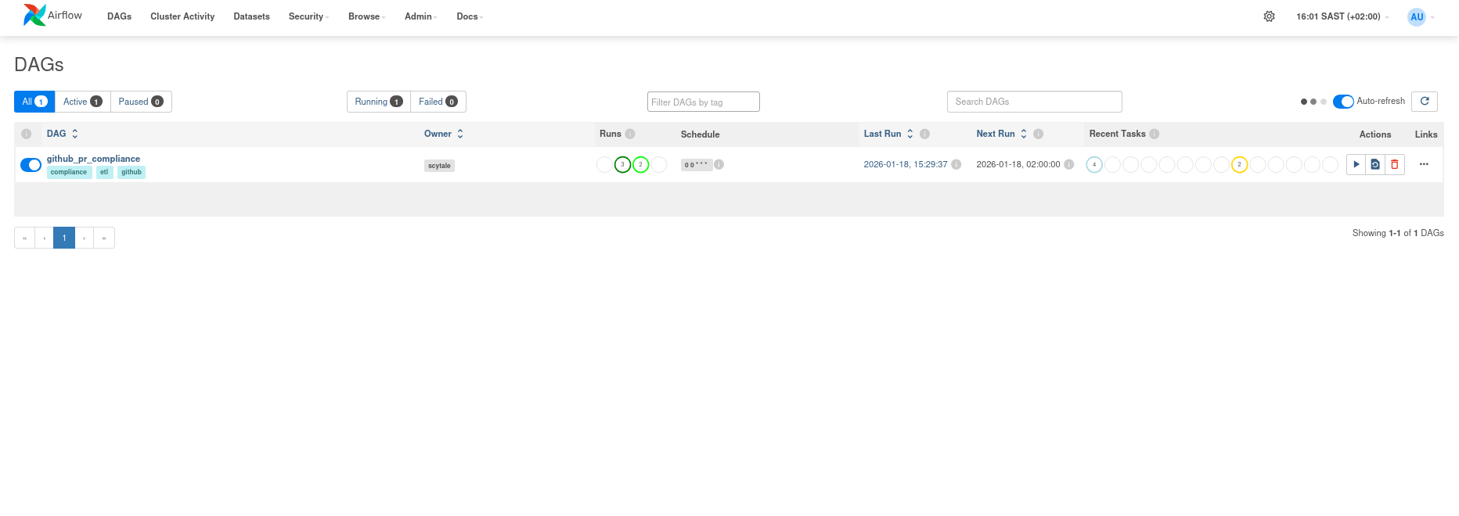

List Dag Runs
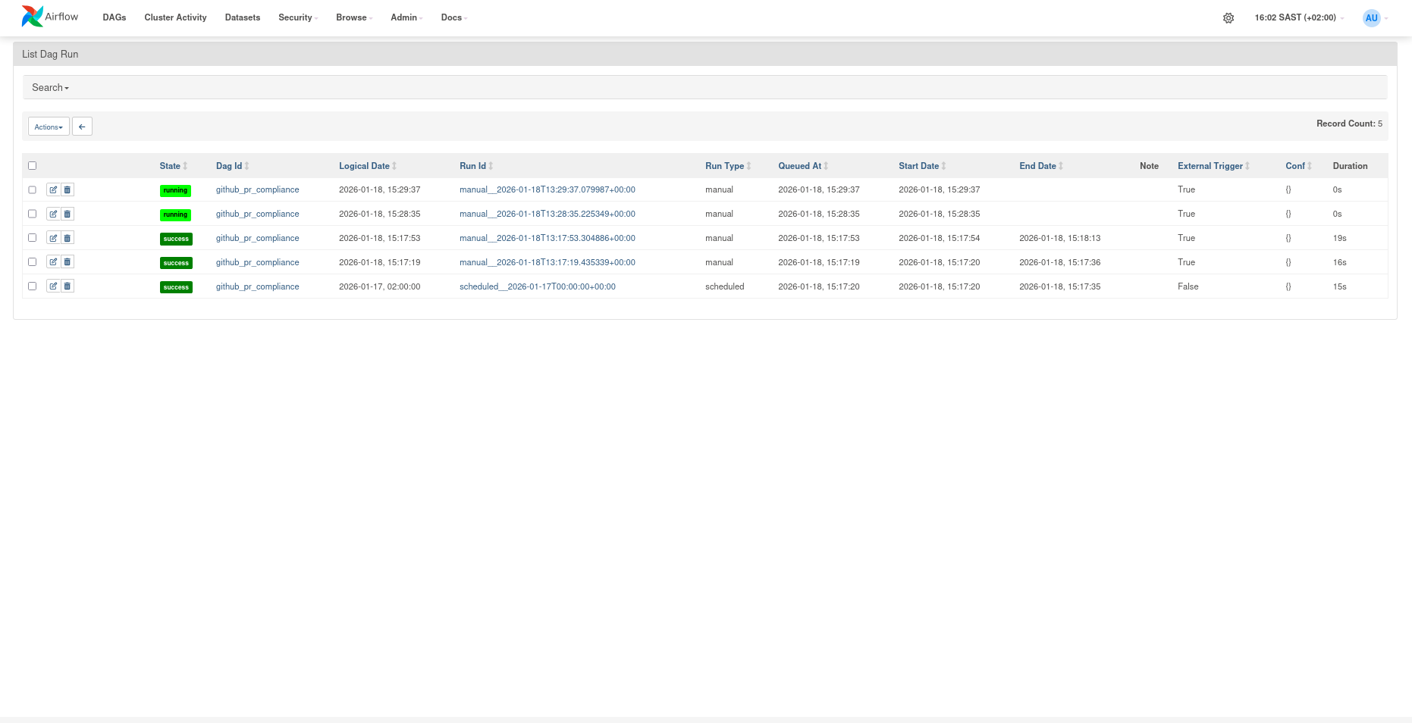

DAG: github_pr_compliance
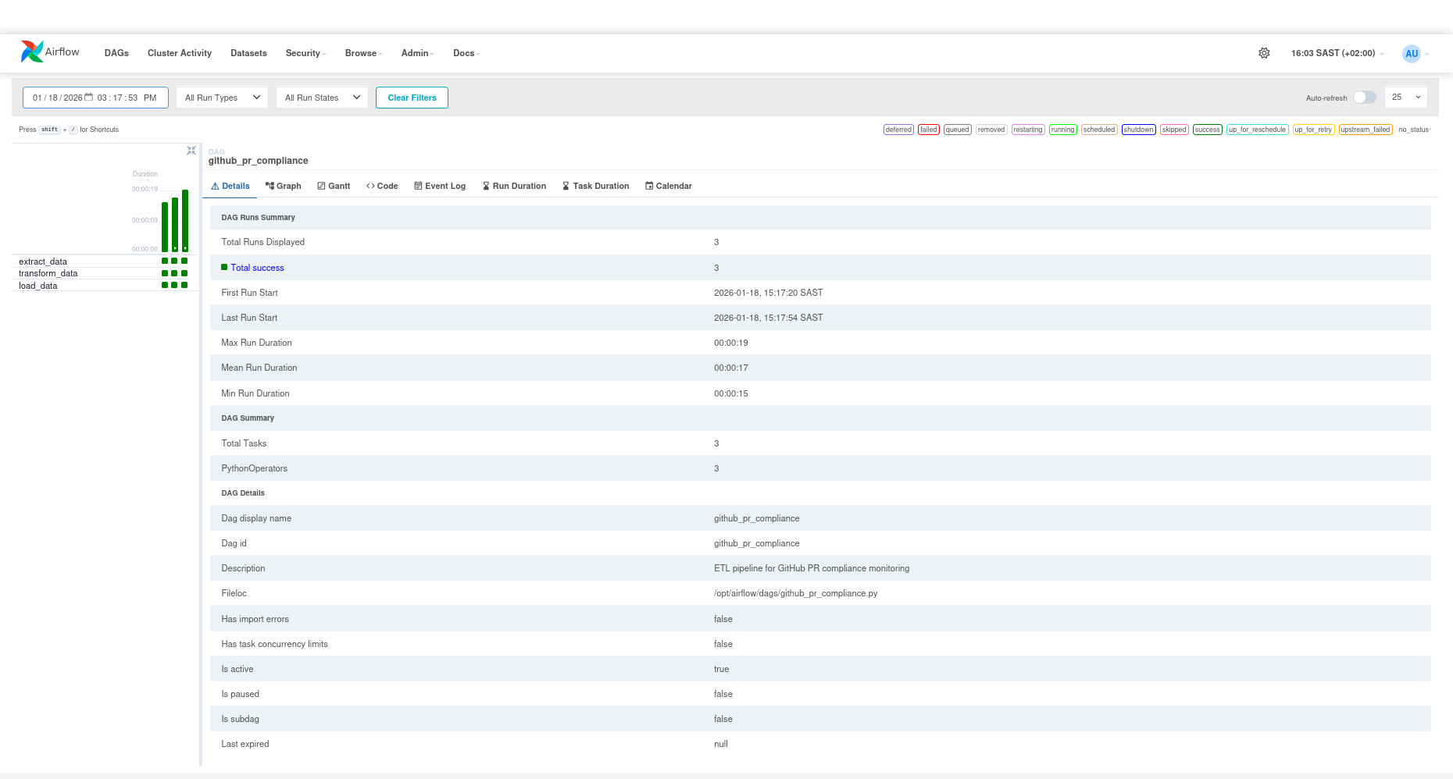

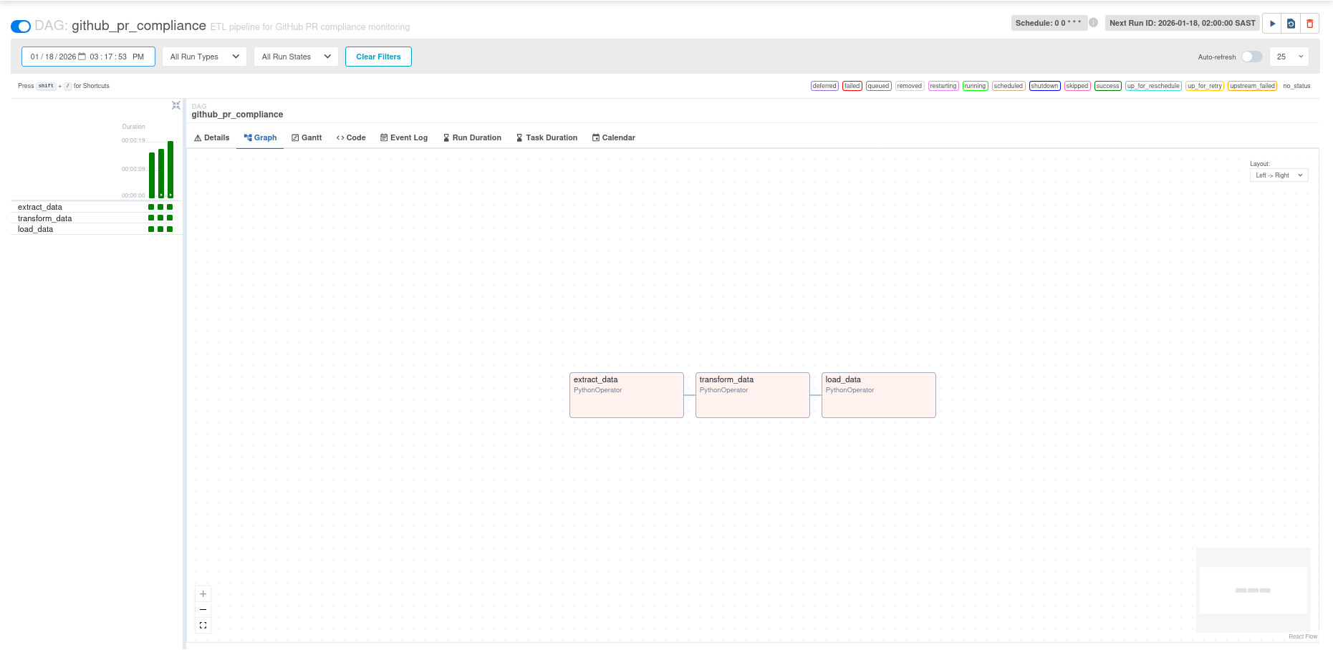

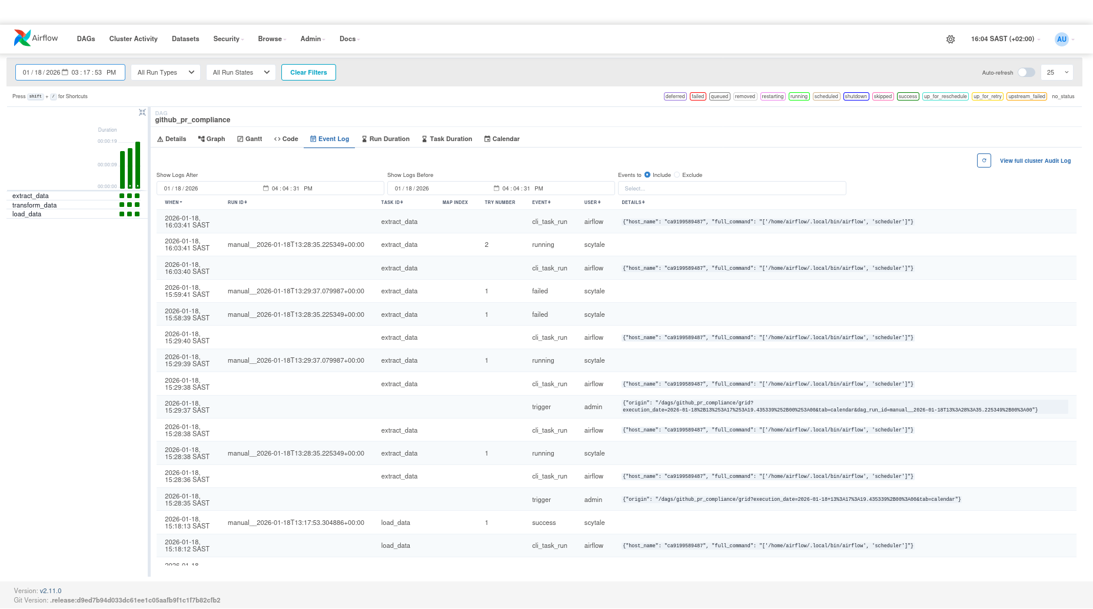

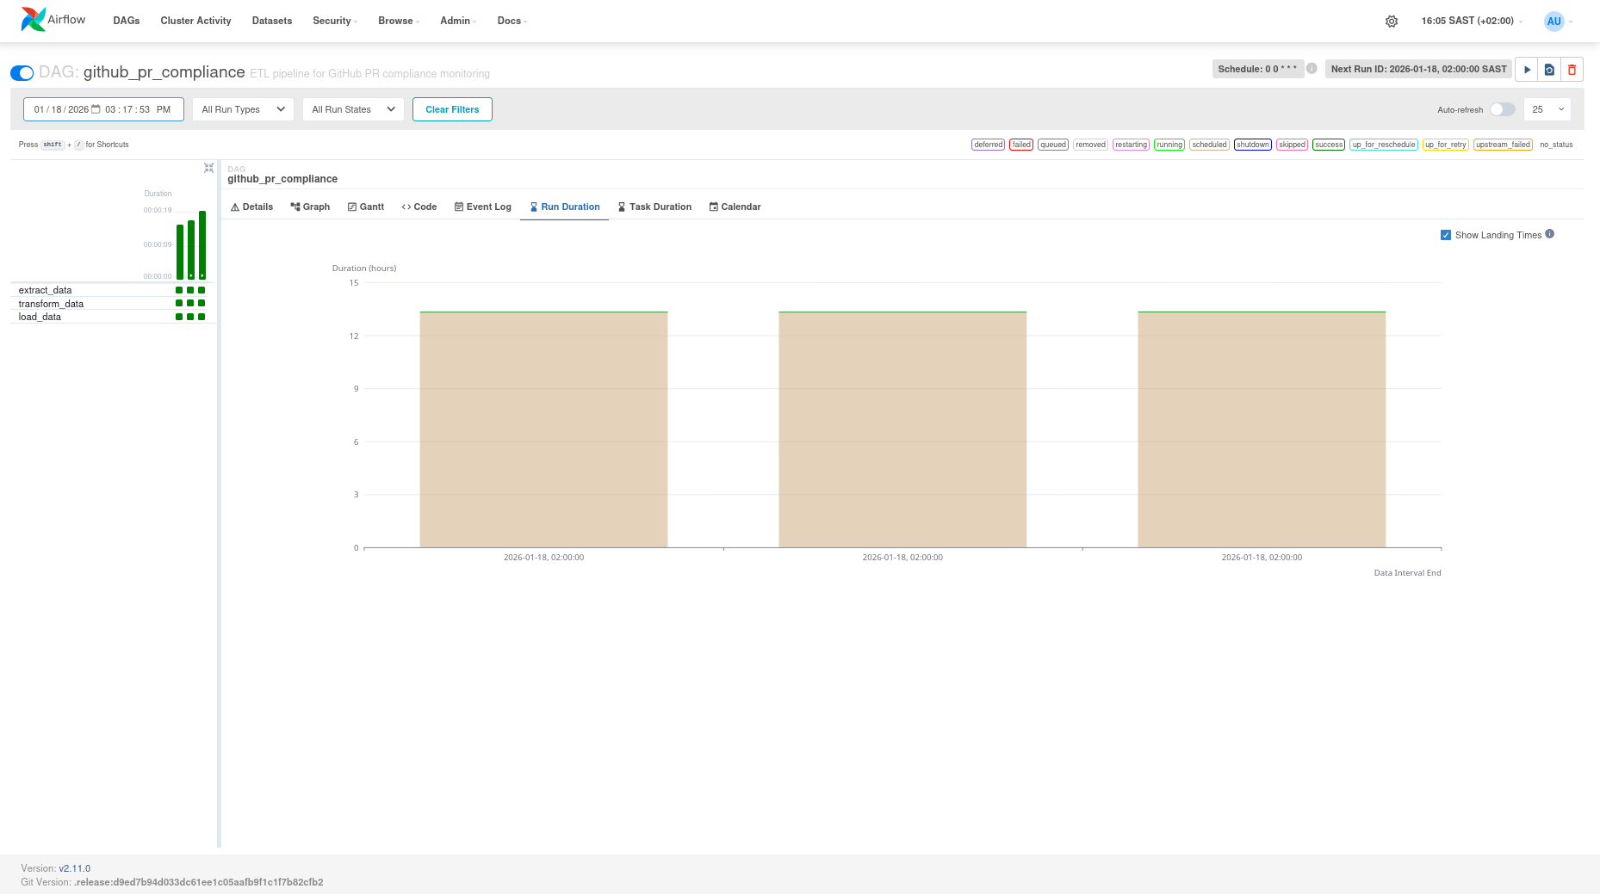

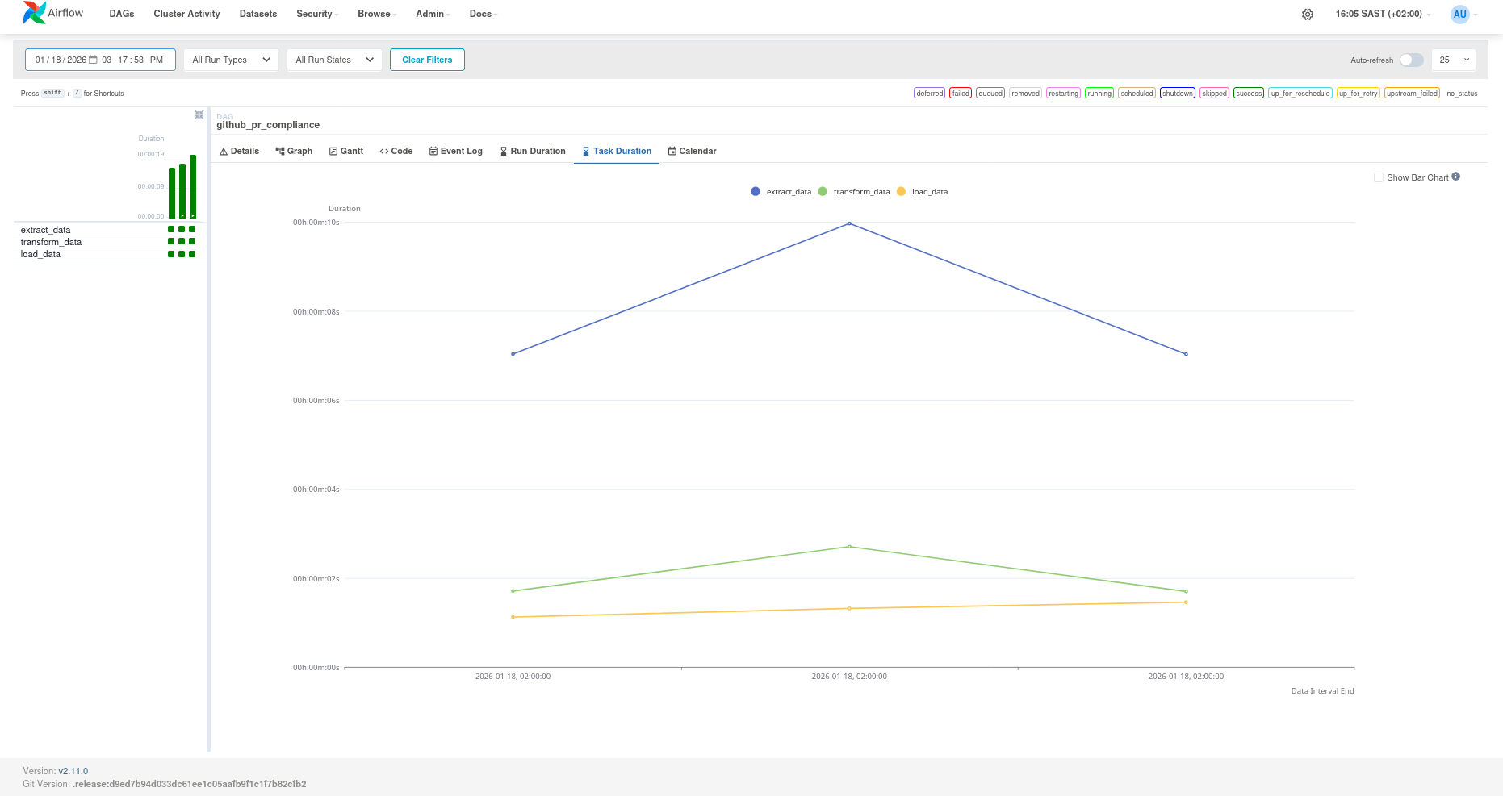

extract_data
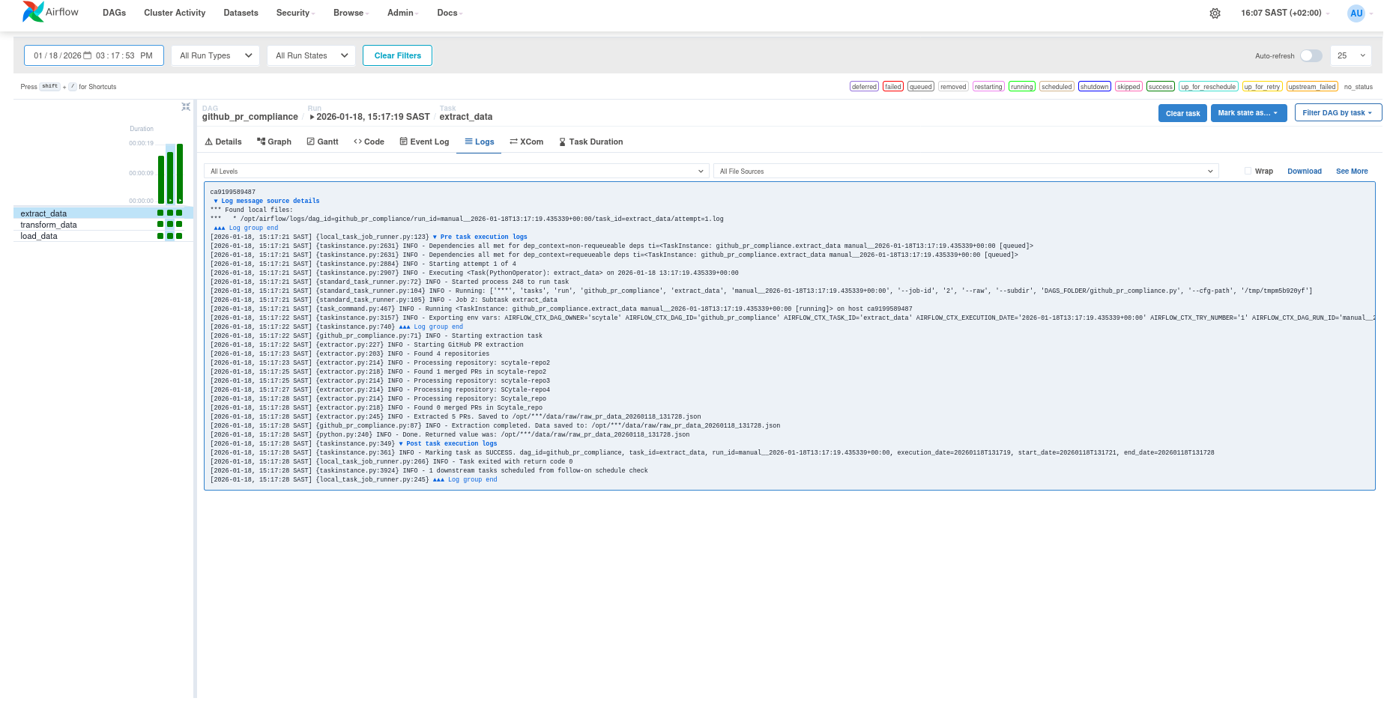

transform_data

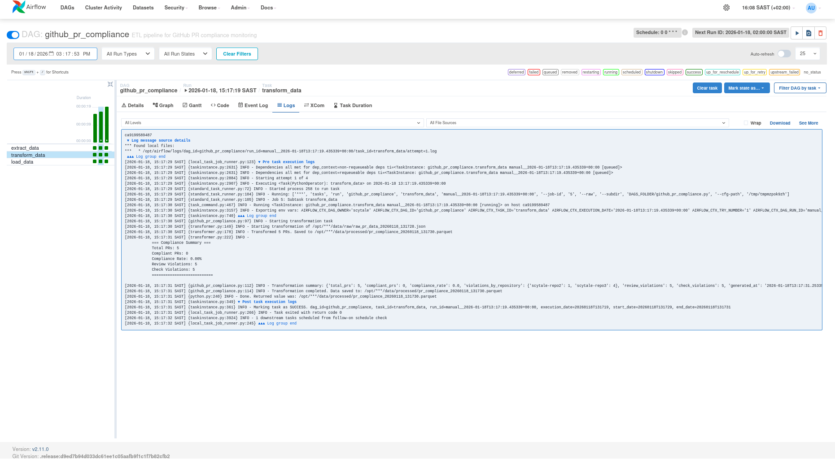

load_data
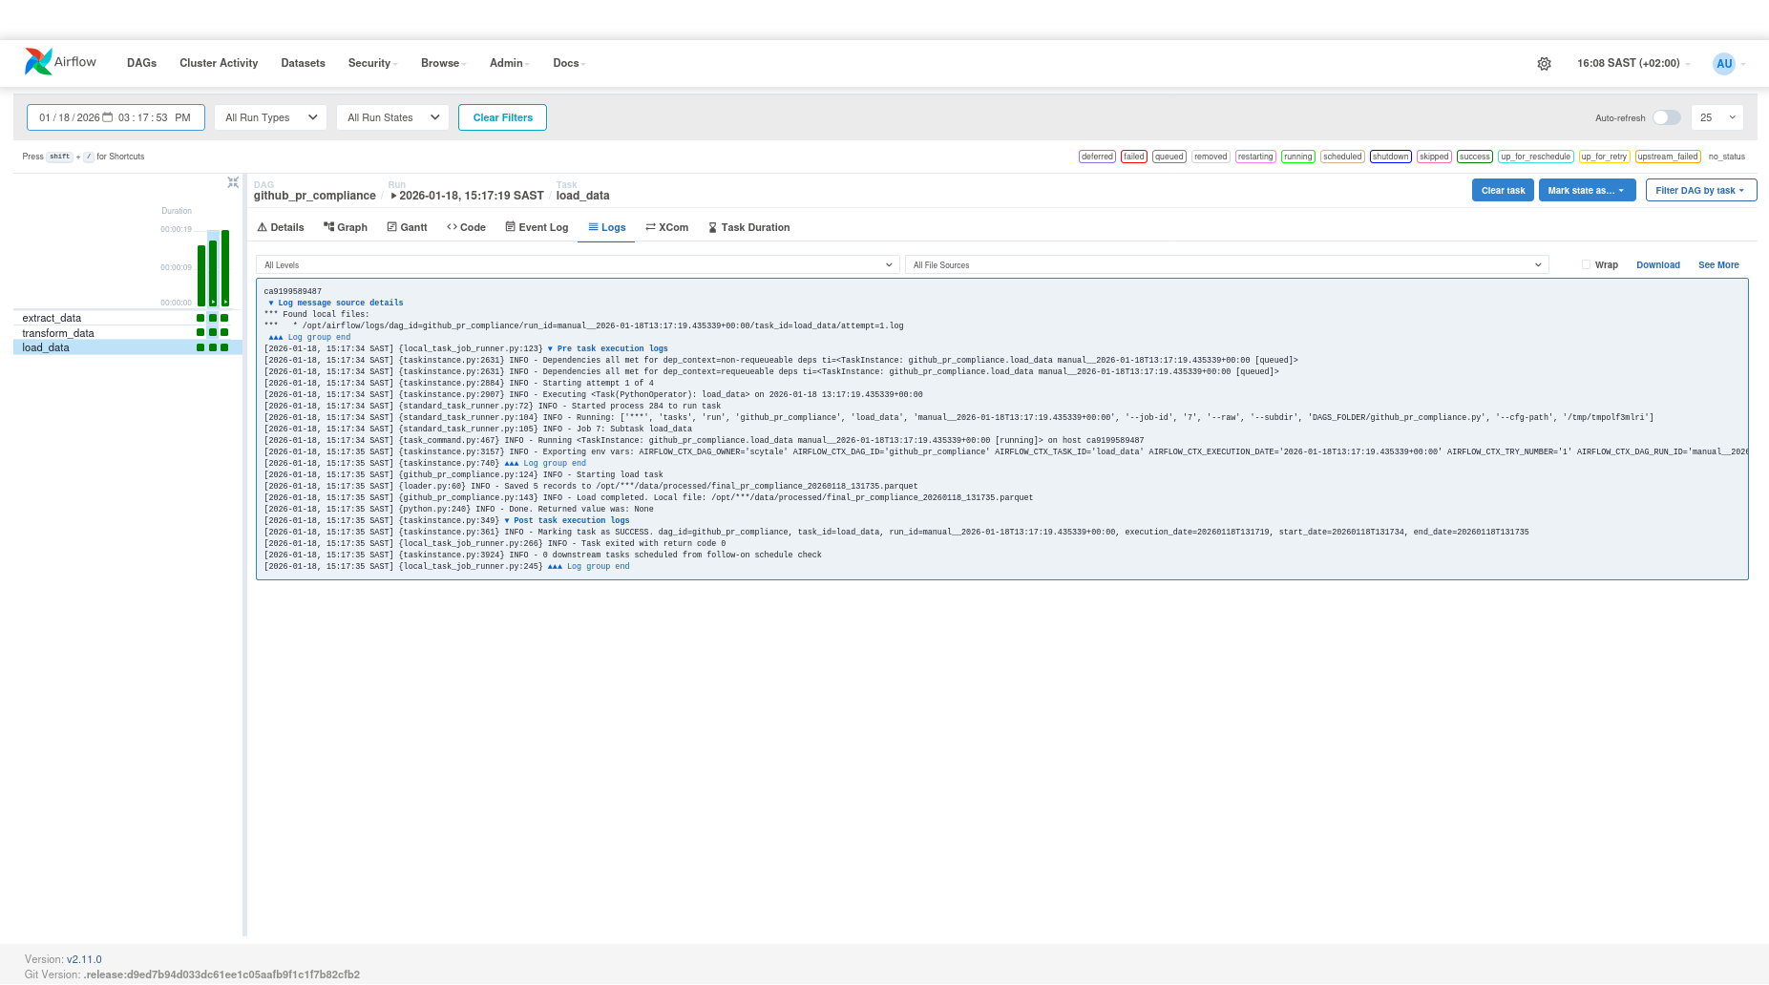

List Jobs
